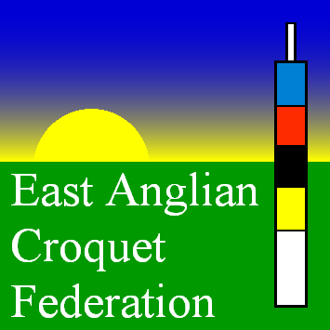
EAST ANGLIAN CROQUET FEDERATION
Application for a Development Grant

Fill in this form as completely as you can. All information will assist the committee in making a decision regarding this application. This form and any attachments should be submitted electronically (MSWord or pdf files are acceptable) to your Federation Development Officer, Jonathan Toye, e-mail: jonathantoye@hotmail.com. A club will only be eligible to apply for one grant in any 3 year period.
Date of Application

Name of Club
Name of Project or Item(s)
Estimated total Cost
Amount of grant you are seeking from EACF. (NOTE the maximum grant is £500)
Project Description
Project Objectives
What do you expect to achieve
e.g.
Increase membership
Improve lawn quality or essential off-court facilities
Prevent closure of an existing club
Help re-establish an existing club; typically after relocation

Application for a Development Grant

What are the sources and amounts of funds available in addition to this application?
Has the membership approved the project?

When do you expect the project to start and finish?

How many members do you have?

How many courts do you have? Please describe them

What facilities do you have?

Club Contact Details. Please note this application should be submitted by an Officer of the Club
Name
Role in the club
Address
Telephone
Email address

